Miramar Peninsula: Subdivision or parkland?
Dave Burgess21:42, Jul 07 2011
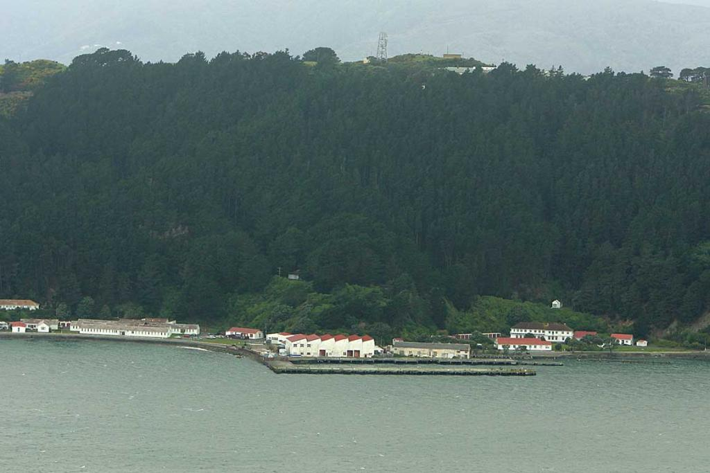
1 OF 3CRAIG SIMCOX/DOMINION POST
The hill above Shelley Bay, with Wellington Prison on top.
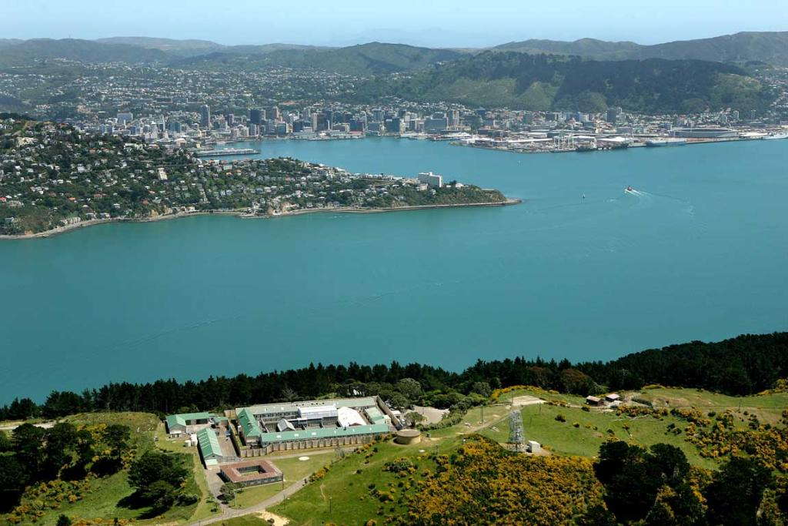
2 OF 3ANDREW GORRIE/DOMINION POST
A view showing the hill above Shelley Bay and Wellington City behind it.
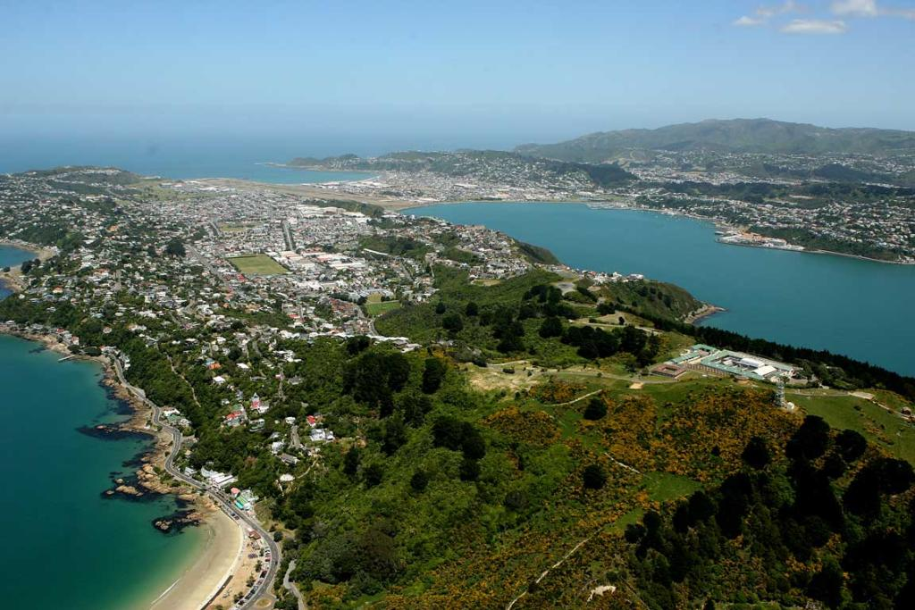
3 OF 3ANDREW GORRIE/DOMINION POST
A view showing the Miramar and Wellington Airport.
The Defence Force is looking to sell a large chunk of historically significant land on Miramar Peninsula and its plans include about 150 homes in "clustered heritage communities".
But the Conservation Department and Historic Places Trust consider the land of national historical significance and will recommend to the conservation minister that it be fully protected as a reserve.
Defence owns 76 hectares of surplus land on what it calls Watts Peninsula. About 14ha would be suitable for rezoning to create 150 residential building sites, says a report entitled Watts Peninsula: Lifestyle-Heritage-Community-Living Together. The homes would be a mix of detached, semi-detached and terrace-style, and owners would pay a fee to a body established to protect, enhance and maintain the heritage features.
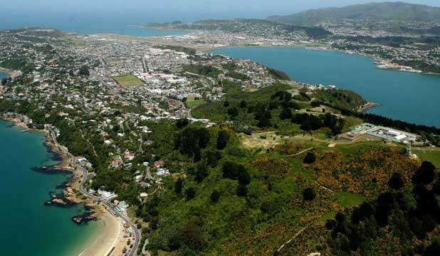
ANDREW GORRIE/DOMINION POST
HERITAGE LAND: Ken New says the Defence Force's plan would destroy many of the area’s most valuable attributes.
The vision would preserve historic military gun emplacements, pa sites and former ammunition magazines, and create six conservation areas.
New recreation links suitable for walking, running and cycling would be created to provide access to the coastal road, Scorching Bay beach, Shelly Bay, and Fort Ballance, on the northern tip of the peninsula. A new road would run along the historic magazine road to join Nevay Rd.
A Defence source confirmed the land was being prepared for "disposal" under the Public Works Act, which ensures that those with a recognised interest in the land get priority when it is sold. Cabinet rules require that fair market value is paid for the land, which has a current rateable value of $7.26 million.
ADVERTISEMENT
If the land is not sold under the terms of the act, the Port Nicholson Block Settlement Trust, which already owns much of Shelly Bay, has first right of refusal. If the trust does not buy the block, it would be put on the market. The trust did not reply to Dominion Post questions.
The Watts Peninsula report was commissioned "to stimulate discussion and provide a possible concept for the future of the property that could best support the mixed interests", the source said.
"In this case, the Historic Places Trust has made recommendations and the Conservation Department is considering its requirements for a `conservation purposes' public work."
DOC Wellington manager Rob Stone said protection of the entire peninsula would be recommended to Conservation Minister Kate Wilkinson. "We see Watts Peninsula as being particularly suited for a city or regional park and for the management to be vested in the city or regional council, with DOC involved at a level of providing technical assistance."
Several parties were interested in the peninsula, Mr Stone said. "If the land is transferred to DOC, then we would work with these parties, including tangata whenua, to manage the site." A spokesman for Ms Wilkinson said she expected to be formally briefed on the issue within a couple of weeks.
Historic Places Trust central region general manager Ann Neill said: "We will be working with the parties to ensure the site is recognised and appropriately protected."
Colin Ryder, of the Watts Peninsula Coalition, said the housing proposal would be a blight. "With medium to high-density housing you could, literally, be looking at 200 to 300 residences and, with subdivision on up to 45-degree slopes, there would need to be extensive earthworks."
The Dominion Post

